Automotive Engine Developments ltd

Land Rover 300tdi engine conversion kit
- Kit Contents:
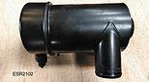  Air cleaner | 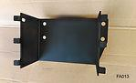  Air cleaner cradle | 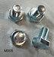  Air Cleaner Cradle Fixings
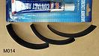  Cradle Rubber Strips and Adhesive | 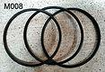 Air cleaner securing rings | 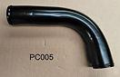 Air Cleaner Inlet Trumpet
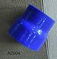 Air Cleaner to Trumpet Hose | 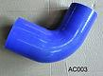 Air Cleaner to Metal Link Hose | 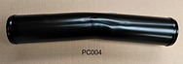Air Cleaner Metal Link to Turbo Inlet Tube
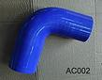 Air Cleaner Metal Link to Turbo Inlet Tube Hose | 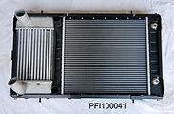Radiator - combined oil cooler / intercooler | 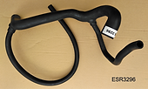 Coolant bottom hose
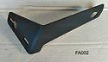 Radiator top left hand support bracket | 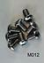 Radiator frame replacement screws | 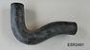 Top hose
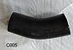 Top Hose Extension | 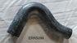 By-Pass Hose | 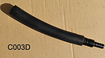 Bottom Hose Extension 2.5D
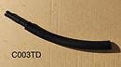 Bottom Hose Extension 2.5TD | 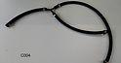 Coolant aerator system | 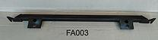Radiator bottom support
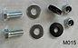 Radiator bottom support fixings | 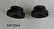 Radiator top grommets | 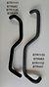 Heater hoses
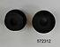 Radiator bottom grommets | 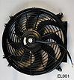 Ventilator | 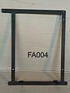 Ventilator mounting frame
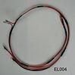 Ventilator sub-loom | 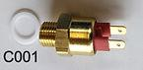 Ventilator thermostat switch | 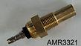 Temperature sender
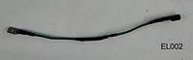 Temperature sender link with resistor | 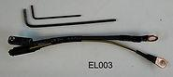Alternator adapter link with allen keys | 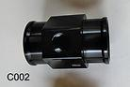 Ventilator thermostat housing
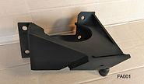 Engine Support RH | 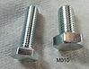 Engine Support Additional Fixings | 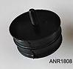 Engine Rubber Mounting RH
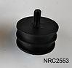 Engine Rubber Mounting | 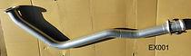Front Pipe 90 / 110 | 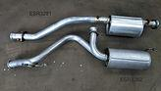 Exhaust System 90
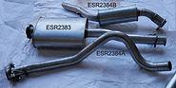 Exhaust System 110 | 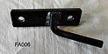 Exhaust Support under transfer box 90/110 | 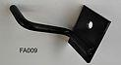 Centre Exhaust Support 90
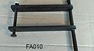 Rear RH Chassis Silencer Support 90 | 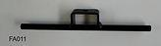 Rear Silencer support LH 90 | 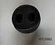 Exhaust Rubber Mountings
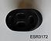 Exhaust Rubber Mountings | 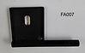 Centre Exhaust support 110 | 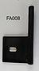 Rear Silencer Support 110
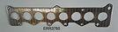 Manifold Gasket | 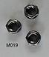 Front Pipe nuts | 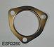 Front Pipe shim
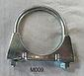 Rear Exhaust Clamp 110 | 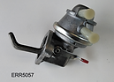 Lift Pump | 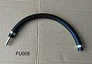 Tank to Lift Pump hose
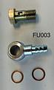 Fuel Injection Pump Banjo | 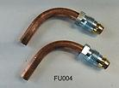 Filter 90° Unions | 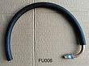 Lift Pump to Filter Hose
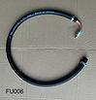 Filter to Injection Pump Hose | 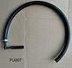 Injection Pump Return Hose | 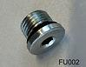 Filter Return Blanking Plug
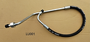 Oil Cooler Pipes | 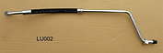Oil Cooler Pipes | 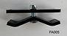 Oil Cooler Pipes Steady Bracket
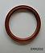 Crankshaft Rear Oil Seal | 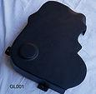 Fibreglass Serpentine Belt Cover | 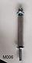 Cover Hexagon mounting
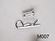 Cover top fixing | 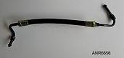 Power Steering Hose LHD | 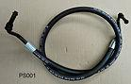 Power Steering Hose RHD
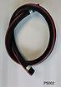 Pump to Reservoir Hose | 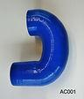 Elbow - Turbo Inlet | 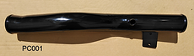Turbo Inlet Pipe
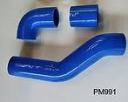 Turbo Output Silicone Hoses | 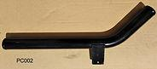Turbo Output Pipe | 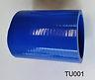 Turbo Output Extension Hose
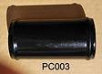 Turbo Output Link | 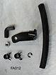 Wastegate Clevis Kit LHD | 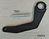 Injection Pump Timing Tool
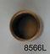 Crankshaft Spigot Bush | 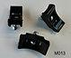 Ventilator Frame Saddles for Hoses

All fixings that cannot be taken from the 2.5D/TD engine are supplied in the kit, all hose clamps are supplied.
Through ongoing development, some photos may change.

